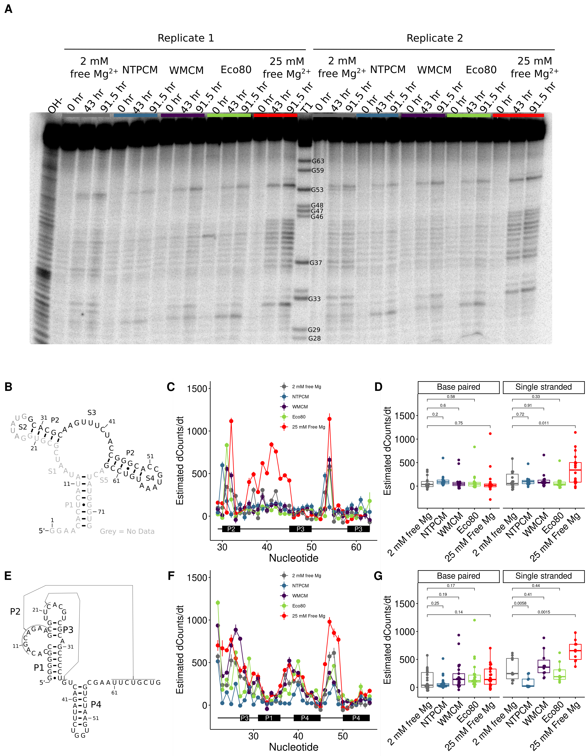

**Figure 2** *E. coli* metabolite and Mg2+ mixtures stabilize the chemical structure of RNA. **(A)** Raw degradation assay gel image for the Guanine riboswitch aptamer incubated in artificial cytoplasms at 37 °C and pH 7. The OH- lane contains a hydrolysis ladder which cleaves after every nucleotide and T1 contains the RNA treated with T1 ribonuclease which cleaves after every G. Enough Mg2+ was added to each artificial cytoplasm to have 2 mM Mg2+  as determined in Figure 1. **(B)** Secondary structure of the guanine riboswitch aptamer. **(C)** Estimated increase in counts as a function of time at each residue in different solution conditions as a function of location in the RNA. **(D)** Estimated increase in counts as a function of time in different conditions grouped by paired and unpaired bases. Significance was determined using a student’s t-test. **(E)** Secondary structure of the cleaved human CPEB3 HDV ribozyme. **(C)** Estimated increase in counts as a function of time at each residue in different solution conditions as a function of location in the RNA. **(D)** Estimated increase in counts as a function of time in different conditions grouped by paired and unpaired bases. Significance was determined using a student’s t-test.

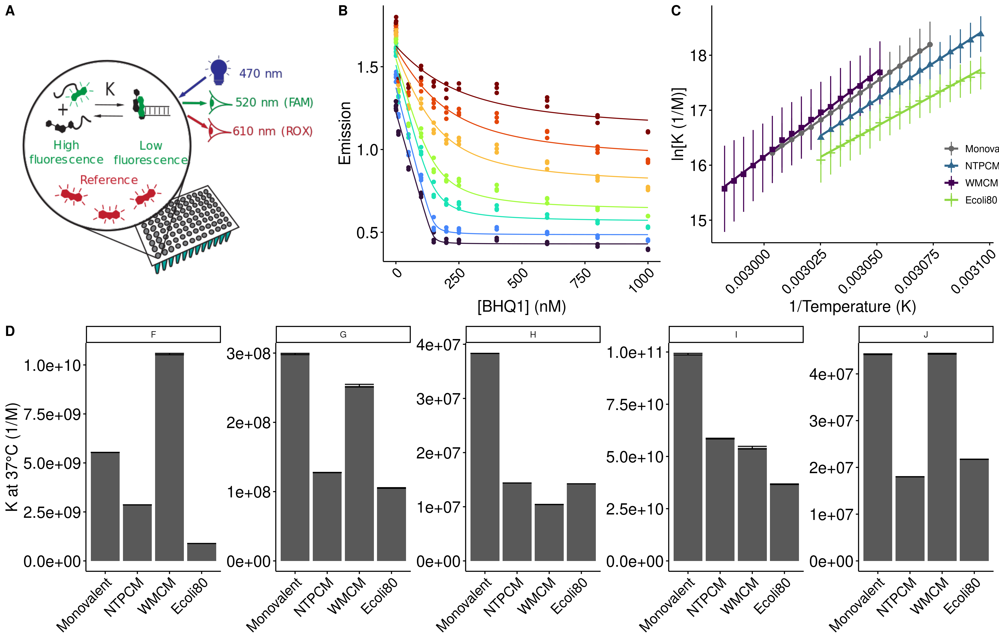**Figure 3** *E. coli* metabolite and Mg2+ mixtures destabilize RNA secondary structure.

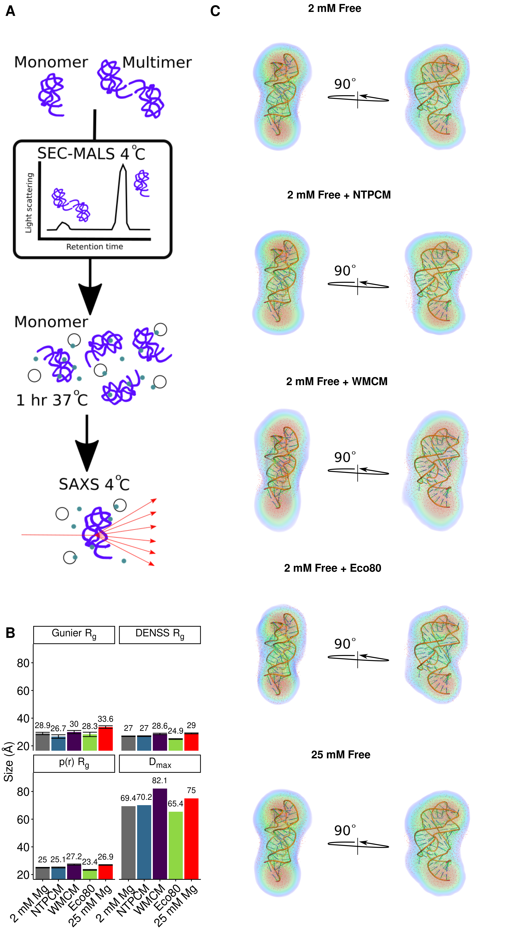

**Figure 4** *E. coli* metabolite and Mg2+ mixtures increase functional RNA compactness.

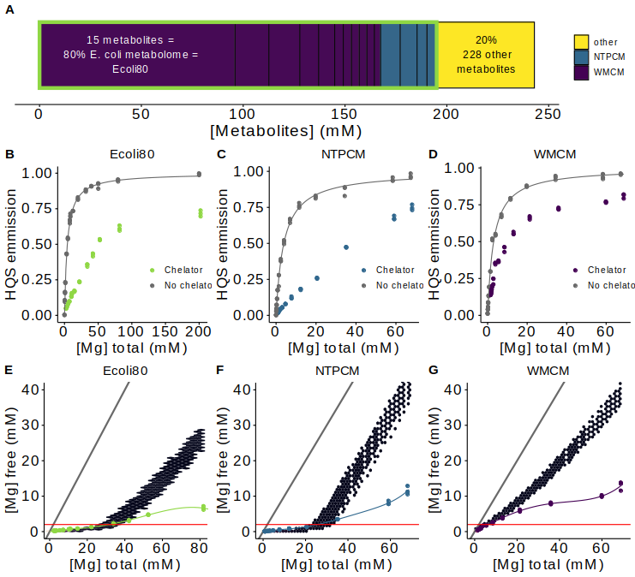

**Figure 1** *E. coli* metabolite and Mg2+ mixtures approximate single site binding near 2 mM free Mg2+. **(A)** E. coli metabolome molar composition. **(B-C)** Effect of Mg2+ on 8-hydroxyquinoline-5-sulphonic acid emission with and without mixtures of metabolites that chelate Mg2+. Grey lines represent fits to determine the binding constant for Mg2+ and HQS. **(E-F)** Effect of the total Mg2+ concentration on the free Mg2+ concentration with mixtures of metabolites that chelate Mg2+. Free Mg2+ was calculated using HQS emission and the binding constant for Mg2+ and HQS. Grey lines represent the free Mg2+ concentration in the absence of chelators (free Mg2+ = total Mg2+). Hex bins represent a statistical simulation based on experimental errors in KD determination, experimental errors in reagent concentrations, and single site binding.

Table 1. The top 14 most abundant metabolites that comprise 80% of the E. coli metabolome.

|  |  |  |  |
| --- | --- | --- | --- |
| Metabolite | Conc. (mM) | K’D  (mM) | Chelation stength |
| ATP | 9.63 | 0.276 (0.272 to 0.279)a | Strongc |
| UTP | 8.29 | 0.238 (0.230 to 0.245)a | Strongc |
| GTP | 4.87 | 0.201 (0.195 to 0.208)a | Strongc |
| dTTP | 4.62 | 0.160 (0.153 to 0.166)a | Strongc |
| L-Glutamic acid | 96 |  | Weakc |
| Glutathione | 16.6 |  | Weakc |
| Fructose 1,6-BP | 15.2 | 5.9 (5.6 to 6.2)a | Weakc |
| UDP-GlcNAC | 9.24 | 29.0 (28.4 to 29.6)a | Weakc |
| Glucose 6-P | 7.88 | 17.3 (16.8 to 17.7)a | Weakc |
| L-Aspartic acid | 4.23 |  | Weakc |
| L-Valine | 4.02 |  | Weakc |
| L-Glutamine | 3.81 |  | Weakc |
| 6-P-gluconic acid | 3.77 | 14.4 (5.6 to 6.2)a | Weakc |
| Pyruvic acid | 3.66 |  | Weakc |
| Dihydroxyacetone phosphate | 3.06 | 19.7 (19.2 to 20.2)a | Weakc |

aDetermined at 37 °C with Isothermal titration calorimetry. Error is the propagated standard error in the fit parameter.

cmetabolites with KDs for Mg2+ less than 2 mM are considered strong Mg2+ chelators.

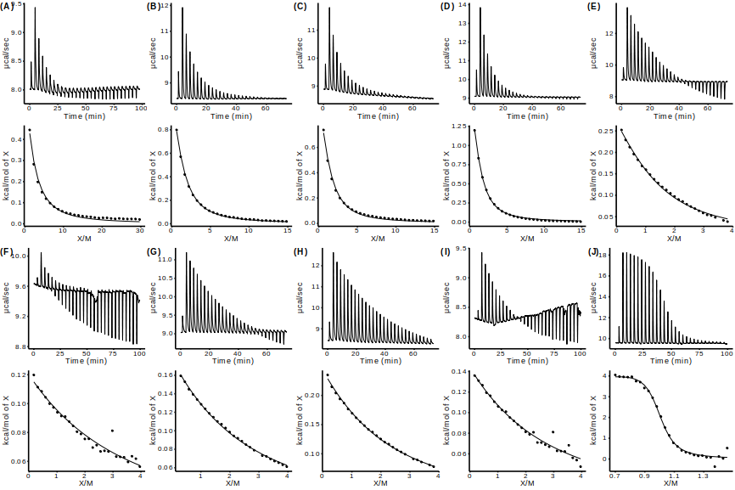

SI Figure 1 Isothermal titration calorimetry (ITC) analysis of Mg2+ binding to metabolites.

SI Table 2 Apparent binding constants determined with Isothermal titration calorimetry (ITC).

|  |  |  |  |  |  |
| --- | --- | --- | --- | --- | --- |
| Metabolite | Syringe (mM) | Cell (mM) | dH (kcal/mol) | K’ (M-1) | KD’ (mM-1) |
| ATP |  |  | 1.83 (0.04) | 3600 (200) | 0.28 (0.01) |
| UTP |  |  | 1.70 (0.01) | 4200 (70) | 0.248 (0.004) |
| GTP |  |  | 1.43 (0.02) | 5000 (200) | 0.201 (0.007) |
| dTTP |  |  | 2.19 (0.02) | 6300 (300) | 0.160 (0.003) |
| Fructose 1,6-BP |  |  | 0.414 (0.004) | 169 (4) | 5.9 (0.1) |
| UDP-GlcNAC |  |  | 0.57 (0.02) | 34 (2) | 29 (2) |
| Glucose 6-P |  |  | 0.555 (0.003) | 57.9 (0.7) | 17.3 (0.2) |
| 6-P-gluconic acid |  |  | 0.662 (0.005) | 70 (1) | 14.4 (0. |
| Dihydroxyacetone phosphate |  |  | 0.50 (0.01) | 51 (3) | 20 (1) |
| EDTA |  |  | 2.85 (0.04) | 220,000 (30,000) | 0.0045 (0.0006) |

SI Table 3 Apparent binding constants determined with HQS emission.

|  |  |  |  |  |  |
| --- | --- | --- | --- | --- | --- |
| Metabolite | Fmax | Fmin | KHQS (mM-1) | K’ (mM-1) | KD’ (mM-1) |
| L-Glutamic acid | 187,000 (1000) | 0 (810) | 0.281 (0.008) | 0.0096 (0.001) | 117 (13) |
| Glutathione |  |  |  |  |  |
| L-Aspartic acid | 196,000 (1000) | 0 (824) | 0.283 (0.007) | 0.0068 (0.0003) | 149 (7) |
| L-Valine |  |  |  |  |  |
| L-Glutamine | 190,000 (1100) | 516 (1060) | 0.266 (0.010) | NAc | NAc |
| Pyruvic acid |  |  |  |  |  |

cNo binding observed as per SI Figure 2

Table 2. Stability of RNA helices in *E. coli* **metabolite mixtures.**

|  |  |  |  |  |  |  |  |
| --- | --- | --- | --- | --- | --- | --- | --- |
| Helix | Sequence (5'-FAM/ BHQ1-3') | AU  content | Condition | dH (kcal/mol) | dS (cal/mol/K) | dG (kcal/mol) | ddG (kcal/mol) |
| F | CGCAUCCU/AGGAUGCG | 0.38 | 2 mM free | -55.9 (0.2) | -136.0 (0.7) | -13.82 (0.01) |  |
| NTPCM | -52.2 (0.4) | -125 (1) | -13.41 (0.02) | 0.41 (0.02) |
| WMCM | -61.4 (0.8) | -152 (2) | -14.22 (0.05) | -0.40 (0.05) |
| Ecoli80 | -44.5 (0.7) | -102 (2) | -12.70 (0.04) | 1.13 (0.04) |
| G | CCAUAUCA/UGAUAUGG | 0.63 | 2 mM free | -53.4 (1.0) | -133 (3) | -12.02 (0.04) |  |
| NTPCM | -42.9 (0.5) | -101 (1) | -11.50 (0.02) | 0.52 (0.04) |
| WMCM | -53 (2) | -132 (7) | -11.9 (0.1) | 0.10 (0.01) |
| Ecoli80 | -57 (2) | -146 (5) | -11.38 (0.05) | 0.64 (0.06) |
| H | CCAUAUUA/UAAUAUGG | 0.75 | 2 mM free | -53.5 (0.4) | -137 (1) | -10.76 (0.01) |  |
| NTPCM | -45.0 (0.2) | -112.5 (0.5) | -10.158 (0.002) | 0.60 (0.01) |
| WMCM | -43 (2) | -107 (5) | -9.94 (0.02) | 0.80 (0.02) |
| Ecoli80 | -41.3 (0.2) | -100.4 (0.7) | -10.15 (0.01) | 0.61 (0.01) |
| I | CGGAUGGC/GCCAUCCG | 0.25 | 2 mM free | -71.1 (0.8) | -179 (2) | -15.6 (0.06) |  |
| NTPCM | -70.4 (0.6) | -177 (2) | -15.28 (0.05) | 0.32 (0.08) |
| WMCM | -65.5 (2) | -162 (7) | -15.2 (0.2) | 0.4 (0.2) |
| Ecoli80 | -69.7 (0.8) | -176 (3) | -14.0 (0.1) | 0.61 (0.08) |
| J | CGUAUGUA/UACAUACG | 0.63 | 2 mM free | -63.2 (0.9) | -169 (3) | -10.85 (0.02) |  |
| NTPCM | -59 (1) | -157 (4) | -10.30 (0.01) | 0.55 (0.02) |
| WMCM | -67 (1) | -180 (3) | -10.85 (0.02) | 0.00 (0.03) |
| Ecoli80 | -61 (1) | -164 (3) | -10.41 (0.01) | 0.44 (0.02) |